**Week08 Assignment Due Oct 23 (14 points + 2 points extra credit)**

**Analyses of paired data**

Q1. You will use data for figure 1e from the paper below (Ellis et al)

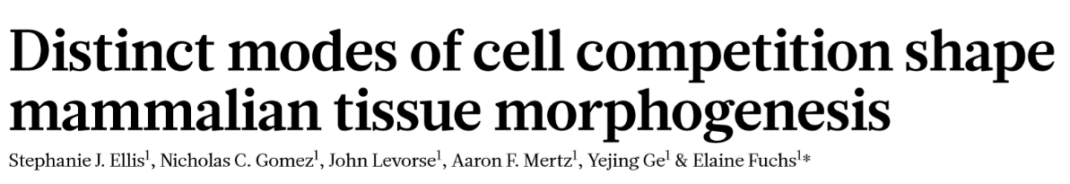

23 MAY 2019 | Vol 569 | Nature

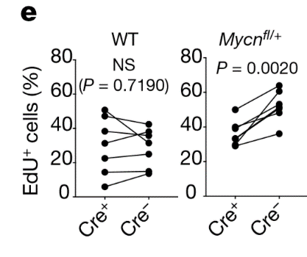

Fig. 1 | Cell competition occurs in the developing mouse epidermis. **e**, EdU incorporation assay (n = 7 regions measured from three embryos per genotype obtained from two independent litters, two-tailed paired t-test).

When I read the description in the figure, I am not certain that the data meet one of the assumptions of a paired test on continuous data, that is the individual pairs (n=7 for wild type and n=7 for Mycnfl/+) are independent. However, for the purposes of this example we will assume that the data meet the assumptions that the data must be paired and the pairs must be independent. It is up to you to determine if the differences meet the assumption of normality and to determine if the paired t-test is appropriate (as the authors used) or if the non-parametric test is the better (least biased) test. For this example, we will use either the parametric or non-parametric tests and ignore data transformation as an option. One caution: I could not match the p-value for the WT group so there may be a discrepancy in the data provided by the author.

Q1a. Finish filling out the table below. (2 pts)

WT diff Mycnfl/+diff

Mean

Median

SD

Skewness

WT diff Mycnfl/+diff

Mean -1.28 14.22

Median 0.36 12.96

SD 7.94 7.33

Skewness -1.49 1.39

Q1b. Copy the Q-Q plots for WT and Mycnfl+/- below. Use a screen capture or some other method but not a direct copy from Prism into Word (the image will not display properly) (1 pt)

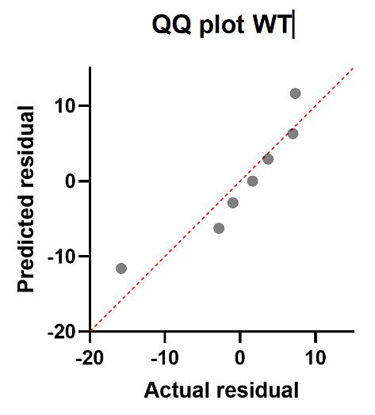 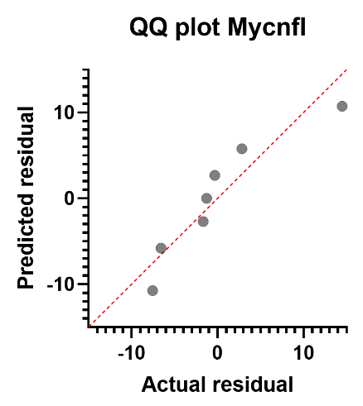

Q1c. Copy side by side box plots (min to max whiskers) for both distributions in the same graph. (1 pt)

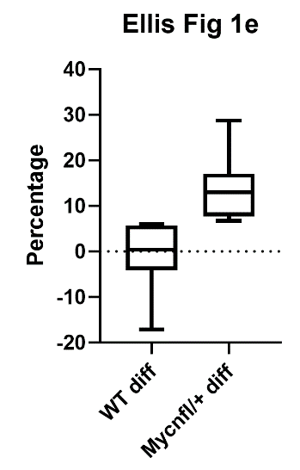

Q1d. Based on the evidence above in Q1a-c, do you think paired t-tests are appropriate tests to answer the question if there is a difference between Cre+ and Cre- percentages in WT? Why or why not? (2 pts)

No, the data for the differences is obviously non-normal. The mean and median are not the same, there is strong left skew. The Q-Q plot does not show symmetry.

Q1e. Do you come to the same conclusion about the Mycnfl/+ data? (1 pts)

Yes, it is also skewed.

Q1f. Perform the analysis for the Mycnfl/+ data using either the paired t-test or the Wilcoxon signed rank test based on your answer to Q1e. Write up the results below. (2 pts)

We tested our hypothesis that there was a difference in the percentage of Edu+ cells between Cre+ and Cre- cells in Mycnfl mice.

The data did not pass the normality assumption of the differences for a paired t-test so we used the Wilcoxon signed rank test and met the assumptions of the Wilcoxon test (data are paired, pairs are independent).

With p=0.02 (two tailed, =0.05), we reject the null hypothesis that the median difference of populations is zero (a median difference of of 12.98 was found) showing that there was an increase in percentage of Edu + cells.

EXTRA CREDIT: Do the least biased statistical test to help you decide if the change in cell percentages was different between WT and Mycnfl/+ groups. Write up your results below. (2 pts)

Due to non-normality, a Mann-Whitney test is used.

The data for both groups failed the normality assumption for an independent t-test so we performed the non-parametric Mann Whitney test.

With p=0.0006 (two-sided Mann-Whitney test, =0.05), we reject the null hypothesis of no difference in rank score distribution of cell percentage differences between WT and Mycnfl/+groups

We conclude that the Mycnfl/+group has larger differences between Cre+ and Cre- groups (median 12.96) compared to the WT group (median of 0.36).

Q2 A researcher conducts a study to investigate whether or not a documentary that is highly critical of the use of animals as subjects in medical research influences public opinion. One hundred randomly selected subjects are administered a pretest to determine their attitude concerning the use of animals in medical research. Based on their responses, subjects are categorized as pro-animal research or anti-animal research. Following the pretest, all of the subjects are instructed to watch the documentary. Each subject’s attitude toward animal research is reassessed. The results of the study are summarized below. The data are paired because the pretest and posttest are done in the same individuals. Each individual is independent. Therefore a McNemar’s test is appropriate to answer the question if the documentary changed public opinion.

If there is a shift in attitude from the pretest to the posttest (specifically from pro-animal research to anti-animal research), one would expect the proportion of subjects in Cell c to be larger than the proportion of subjects in Cell b. Clearly that seems to be the case as seen in the table. Perform a McNemar’s test to help determine if the data support the hypothesis.

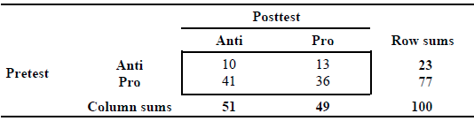

Q2a. Calculate the McNemar’s test by hand. Show your work below. (1 pt)

(13-41)2

13+41

= 784/54 = 14.52

Q2b. From the table below, what is the critical value? (1 pt)

3.841

Chi-square critical values

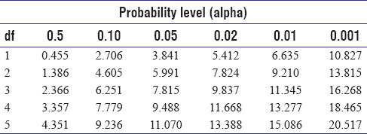

Q2c. Based on the information in Q2a and Q2b, do you reject or fail to reject the null hypothesis and why? (1 pt)

Reject, because 14.52>3.84, then the p-value is less than 0.05.

Q2d. Perform a McNemar’s test in Prism using the QuickCalcs website. Did the documentary change people’s opinion about animal experimentation? Write up your test results including a description of the measure of effect (i.e., do not just report a p-value, but also the magnitude of the change, what percentage were anti-animal experimentation.) You will notice that the Prism Chi-square statistic is smaller than what you calculated above by hand. Prism adjusts the value. (2 pts)

We tested the hypothesis that watching an anti-animal experiment documentary changed the opinion of people about animal experimentation.

We performed a McNemar’s test on the paired data (each person had both the pre -and post-test).

The data met the assumptions of paired data and independent pairs. With p=0.0002 (two-sided, chi-square=13.5, 1 df, a=0.05), we reject the null hypothesis that the marginal cells are equivalent and conclude that the documentary changed people’s minds about animal experimental.

Before the documentary 23% were anti animal research compared 51% after seeing the documentary.